# Product Description

Duolingo was created by a team of Carnegie Mellon students but lead by PhD students, Luis von Ahn and Severin Hacker (Siegler, 2011). The Phython based web application won App of the Year awards for best of iPhone and Android in 2013 and again in 2014 for Android 2014 (Gigaom, 2013). This award winning education application has been sponsored by several organizations including Union Square Ventures, New Enterprise Associates, and Google Capital (Siegler, 2011; Todd, 2012; Venture Capital Dispatch, 2012)

Duolingo is a Python application, which allo­ws a user to learn to speak, read, write, and understand new language(s). Duolingo website states “With over 100 million users, Duolingo has organically become the most popular way to learn languages online in only 2 years” (von Ahn, Luis, 2011).

Duolingo may be run on in a native mobile application, or accessed on desktop or mobile browser. The desktop website (Appendix B) and mobile browser versions of the application (Appendix C) are very similar to the three native mobile versions Android, iOS, and Windows (Appendix D). This evaluation will primarily focus on the Apple iOS version of the Duolingo application, with some cross references to the browser desktop version to note additional resources and features. Duolingo offers courses in 22 different languages and has created special targeted versions of the Duolingo application geared toward self-learning or schools and one towards business 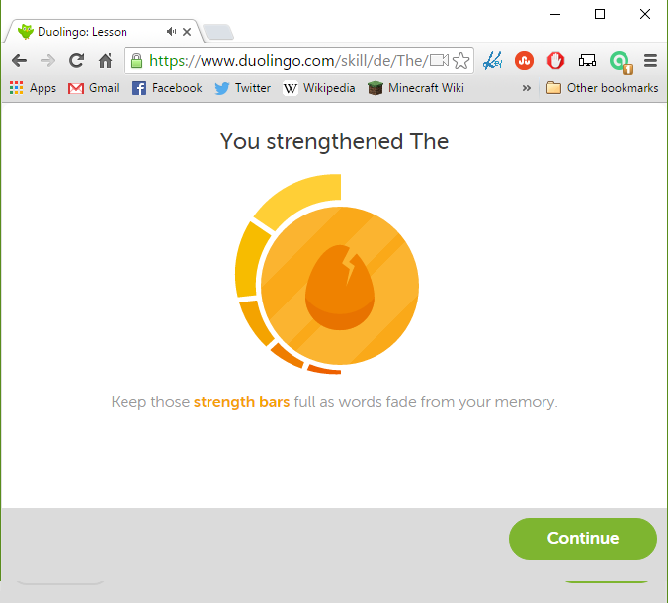with a test in English fluency.

Figure User "Strength" Bar

# Gamification

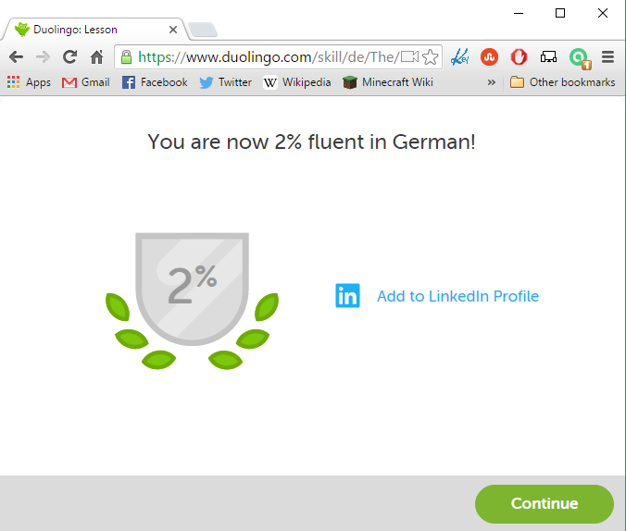Duolingo courses use a game-like concept called Gamification to keep the user interested and keep them moving through the lessons (Other examples of Gamification may be found in Appendix A) . Gamification brings aspects of game theory (Szulborski, 2005) into a non-game activity which can be seen throughout Duolingo (strength meter, levels, “lives”, etc. – Figures 1-3 and Appendix E). Duolingo also gives a user many opportunities to share their progress as they move through the exercises. This social aspect is another key piece of gamification and can help to encourage the user and their friends to continue to use Duolingo.

Figure Fluency Level with opportunity to share on LinkedIn

Figure Level-up Indicator

|  |  |
| --- | --- |
| Duolingo also has an in-app currency called Lingots (Figure 4 Lingots Shop). Users can earn Lingots by increasing their level, learning new skills, finishing levels without errors, or by inviting others to use the app. There is a virtual store where users can purchase items with their Lingots. These items fall into several categories: Power-ups  * Users can earn more Lingots when using the apps or keep their progress if they skip using the app for a day | C:\Users\nst10\Downloads\image19.png  Figure Lingots Shop |
| Outfits (Figure 5 Duo’s Clothing)   * Users can dress their Duo in different outfits to show their friends that they are using the app, progressing, and earning Lingots   Bonus Skills (Figure 5 )   * Purchasing these bonus skills will open more levels for the user and allow them to learn new words and phrases | image20 (1).png  Figure Duo’s Clothing |

# C:\Users\nst10\Downloads\image3 (1).pngCourse of Study

Duolingo has a course of study, which gradually introduces the user to more complex aspects of a language. The course begins with basic terms and sentence structures such as, hello, goodbye, man, woman, child, etc. and graduates to increasingly more complex constructs such as conjugating verbs and common sayings (Figure 6 Choosing a Course). The course of study can be followed by a tree presented to the user. The user can choose a section or subsection within a specific language course, but the exercises for each level always build upon each one and introduce new words and concepts in a linear fashion that is easy for the user to follow. A user also has the option to allow the application to choose various section for them by selecting the practice weak skills button.

Figure Choosing a Course

After the initial basics of the language, Duolingo introduces words and phrases that gives the user the ability to quickly learn common words and phrases to give them a basic level of fluency to communicate if they are on a trip (e.g. food words, travel phrases such as “Where is the Hotel?”, etc.). Users could stop at this level if they are using Duolingo for travel purposes, or could continue to become more fluent in the language.

Inside each course, there are a series of different types of exercises which introduce the words and concepts and allow the user to practice. If the user gets the exercise wrong, they are given the correct answer and tips on what they got wrong. Often, missed questions will come up again later to help reinforce the lesson to the user.

Duolingo also offers more traditional language tools such as tables for conjugating verbs.

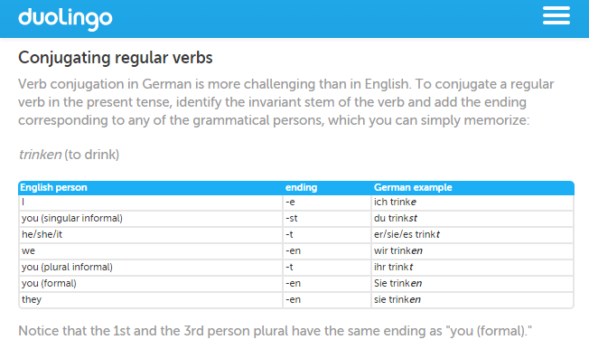

Figure 7 Additional Online Tools - Conjugating Verbs

|  |  |
| --- | --- |
| The exercises in Duolingo fall into four categories: | |
| Figure 8 Web-based Version: Match the word to a picture | Figure 9 Web Version - Translate language being learned to native |
| Figure 10 Translate native language to one being learned | Figure 11 Speak in language being learned |

# Target Audience

## Duolingo can be placed in multiple categories:

1. People wanting to learn a new language for their own enjoyment/benefit
2. People learning a new language for their job
3. Children learning a new language in their school
4. Adults learning a second language at a community college or community course with their progress tracked in-app by the instructor (Figure 11 Progress Sharing).

|  |  |
| --- | --- |
| Some of the Duolingo users already have varying levels of fluency of the language they are studying. They could have a variety of reasons that they would like to use Duolingo including a refresher for their own enjoyment, or for a trip to a foreign country. These users would already have a working knowledge of the language and should be able to quickly work through the exercises. They also have the option to test out of familiar section to quickly move onto harder sections of the course the user wants a refresher on. | Figure Progress Sharing |

Other users are learning new language(s) with little to no fluency. Duolingo offers a wide variety of languages so users who are already fluent in one (or more) of the languages offered could find a course of study in a language that they do not know and it not related to any of the languages they know.

Teachers or private tutors may use Duolingo to train their students in one or more languages in an educational environment. Traditional students in a classroom setting are likely to have little to no knowledge in the language and might be using Duolingo as a requirement for the course or as a companion application to practice. As the students work through the Duolingo courses, the instructor has the ability to track the student’s progress and provide help when needed. This could be used in conjunction with a more traditional, classroom-based mode of teaching languages.

Duolingo also offers tests that people can take to become certified in their level of fluency in English. Users could do this for many reasons, but most would become certified for their job or for a potential job. Users of the English certification test center would most likely be people who do not have English as their first language, but would like to show that they are fluent.

Duolingo can be accessed many different ways for a variety of languages so the target audience for Duolingo’s user base is very diverse. For example, Duolingo users may range from children to senior citizens and come from many different countries, and work in a wide variety of businesses or attend a wide variety of schools. The one thing that all of the users have in common is that they would like to improve their language skills by learning a new language or improving one they already know.

To successfully use the web version of Duolingo, a user would need to have basic knowledge of how to use a computer, web browser, keyboard, mouse, and microphone. Similarly, to use the mobile app a user would have to have knowledge of how to use their mobile phone, how to install apps on the phone, how to access the app, and how to use their phone’s keyboard, touchscreen, and microphone.

Users of Duolingo (especially those who are doing so for personal reasons) have a desire to become fluent (or more fluent) in another language. Their expectations of using Duolingo would be that they should have a core knowledge of the language they are studying to the point that they can read, speak, and understand the language.

# Intended Outcomes

Duolingo is a free language learning tool and a tech based platform aiming to facilitate and assist the learning progress of foreign languages. It supports primarily the curriculum and language services for the early learners. It is currently offering 11 language courses to English speakers (Latin American Spanish, French, German, Brazilian Portuguese and Italian), as well as a variety of other courses (mostly American English, but also Spanish and French) to native speakers of other languages, such as Spanish, French, German, Portuguese, Italian, and many more.

The learning process is accompanied with visual elements and provides a number of different ways to study for new language skills such as listening, reading, speaking and writing which helps users not get bored. Also users can cover all the aspect of the language that make a balance of the learning process. By progressing sets of exercise like answering questions and completing lesson, a user can improve vocabulary and grammar as drills and exercises get progressively more complex and harder.

|  |  |
| --- | --- |
| Each lesson contains 4 types of exercises for translation, listening, matching, and speaking (Figure 12 ). The translation exercise is to translate from your native language to your target language or vice-versa. The activity for a listening exercise is to listen to a short phrase being spoken and write what is heard. In the case of a matching exercise, users are introduced to new vocabulary and need to match it with the right photo or vice-versa. The speaking exercise is an activity in which a user reads out sentences in the learning language. | Figure 13 Visuals for words, hearts to show when your 'losing' gamification, and a progress bar |
| Figure Integration of speech recognition, listening to text, and slowed down pronunciation | |

Duolingo applies the concept of gamification to the program. The strategy of a game format is to motivate users constantly to exert their effort to make progress for the learning. It instills a definite sense of progress on mastering the foreign language when the mission in the game is accomplished. It also has a function of comparing their progress with their friends’ through a social network like Facebook. Much of the learning happens in the form of rapid-fire quizzes, which switch frequently back and forth between questions on speaking, listening, and writing.

The application program guides users for an effective way of learning new language not only by just studying, but also through consistency and repetition. One example of gamification is the point system called a streak that measures how often a user accesses and successfully completes sections of a course within Duolingo.

|  |  |
| --- | --- |
| Cognitive Objectives – Knowledge  * Increase the skills of listening, reading, writing  and number of vocabulary * Be able to understand what they listen * Be able to type what they hear * Be able to translate a target language * Be able to speak with correct accent and   pronunciation * Be able to write a sentence with right   grammar  Affective Objectives- Attitude | weakest-words  Figure 15 Strengthen weak words now or later  (Karch, 2015) |

* Gain confidence with gamification factor of the program.
* Increase concentration with simple User Interface.
* Be self-motivated - motivation is a key factor in language acquisition.
* Experience a self-directed, tech-based learning work
* Grow ability of independent study

### Psychomotor Objectives – Skills

* Be able to have relatively simple conversations with new language.
* Be able to create simple sentences straight away.
* Identify all correct translations of a chunk of spoken or written text
* Identify the English meaning of a vocabulary word

# Preliminary evaluation

## Appropriateness of the materials to the task and audience

Learning a new language can be very difficult. The traditional, classroom-based approach can be very intimidating to a new learner. That approach usually starts with learning simple noun/verb combinations such as conjugating the verb to be (I am, he is, we are, etc.) and builds from there to alphabets, numbers, and simple phrases. Duolingo changes the approach to begin with simple matching exercises and repetition of simple words such as man, woman, boy, etc., going between the user’s native language and the language being learned.

Duolingo puts new language programs through a stringent user testing process. In phase one, volunteer contributors decide on preferred words and topics for the program. Then the program is released into beta for testing. In the beta testing phase, actual users are given the opportunity to try out the program. It has been noted that sometimes users try to prematurely reverse engineer the program to attempt to learn the other language. This happened in the Korean for English speaker’s beta testing. English speakers who wanted to learn Korean got frustrated waiting for the app to be released and attempted to use the English for Korean Speakers program to learn Korean. The results set the beta testing back by months.

Duolingo requires a certain amount of successful course completions and a minimum count of completed courses without sections being flagged for inaccuracy. This was noted frequently in the commentary of Duolingo’s discussion boards, as moderators begged users to only accurately flag items and for English speakers to please wait for their own application because the English for Korean Speakers needed to be released first and Korean for English Speakers was meant to follow up after Phase 3 of English for Korean Speakers. In phase 3 the course within the application graduates and is released for all users. 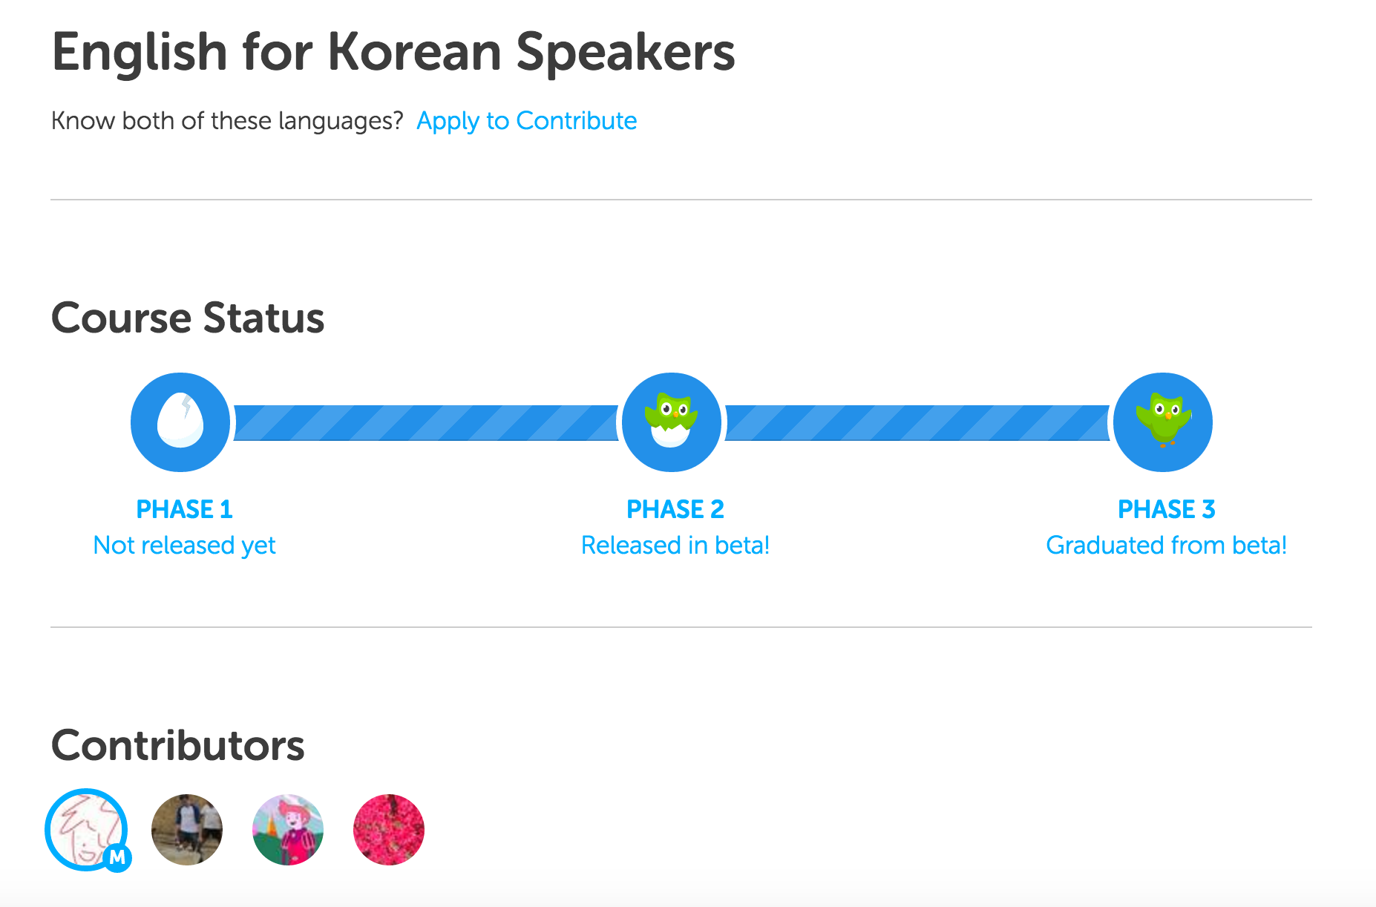

Figure - The setup (beta) phase for new languages - ESL - English for Korean Speakers

# Visual Design

The visual design is very child-like but the adorable owl figure is a brand icon within the Duolingo application.

Figure Duo the brand icon ambassador

The application uses gamification aspects that are becoming more and more common within websites, alternate reality gaming, pervasive games, daily life (Szulborski, 2005), and mobile applications. In Duolingo, Duo the owl, can be dressed up by visiting the application’s shop section. Here, users can also “purchase” more courses or skills to learn. These items may be purchased using a version of currency specific to Duolingo called Lingots. Lingots may be earned by completing courses within Duolingo or practicing and honing skills.

|  |  |
| --- | --- |
| Other items within the shop include freezing your skill level (Figure 17 ). This is a useful item to purchase because you lose experience bars after going a day without using the app. You may also earn extra Lingots by betting on yourself or against the application. The bet is whether or not you can/will consistently login and practice based on your goals for a minimum number of days.  Figure 18 Duo, the brand mascot, encourages users to keep up their progress  Screen Shot 2016-03-04 at 9.00.17 PM.pngC:\Users\nst10\Downloads\image19.png | Figure 19 Duolingo Shop - Freezing your skill |
| Duo will send you reminders to login and practice, but if you ignore him for over a week he will send you I message saying he misses you but doesn’t want to bug you too much and is going to stop sending reminders for a while since those reminders are clearly not encouraging you to practice. | |
| The game aspect of Duolingo continues by offering the user daily streaks, the ability to challenge friends, progress sharing with teachers and friends, and a visual award bar of your experience points for every language you are currently learning. | |

# Strengths and Weaknesses

## Strengths

* **Ease of Use**: Duolingo has gone through stringent user testing for ease of use, a game-like interface, and quality assurance for language accuracy. Users are also consistently encouraged to provide feedback within the application and online within the discussion boards.
* **Placement Test**:
* **Gamification:**
* **Reminders:**
* **Review:**
* **Discuss sentence:** If you do not understand a word of phrase, you can join a forum of other users to try and understand why you are getting something wrong. (Tarter, 2013)

## Weaknesses

* **Internet based**: The application is only available online. This means users on flights, in countries with limited internet access, or in areas with poor reception will not be able to access this tool.
* **Not stand-alone:** You could learn the basics of a language from this application but it may be best to practice with real people.
* **Not enough slang:** All languages have slang. It is hard to understand native speakers if you cannot write and talk the way they do. It also does not teach dialects.
* **You start to loose progress immediately (within a day or so):** This may also be considered a strength.
* **Not enough user feedback:** The mobile application doesn’t have a lot of options to provide feedback.

# Appendix A

## Examples of other apps using Gamification

|  |  |
| --- | --- |
| * Listia *(Figure 12 Listia User Profile Options)* * Badgeville * Frequent flyer programs | Screen Shot 2016-03-04 at 8.49.51 PM.png Screen Shot 2016-03-04 at 8.49.43 PM.png  Figure 20 Listia User Profile Options – Listia using gamification in multiple ways. Users sell or auction items in a similar fashion to the popular selling site, eBay. One main difference between eBay and Listia is that everything on Listia is “free” or sold using credits. Credits can be earned in multiple ways including: experience points, selling items, buying items and commenting, reporting posts, sharing posts, and performing other actions. Users also earn badges, experience levels, titles, and additional features within the site. (Chuang & Fong, 2009) |

# Appendix B

## Desktop Web Browser Application

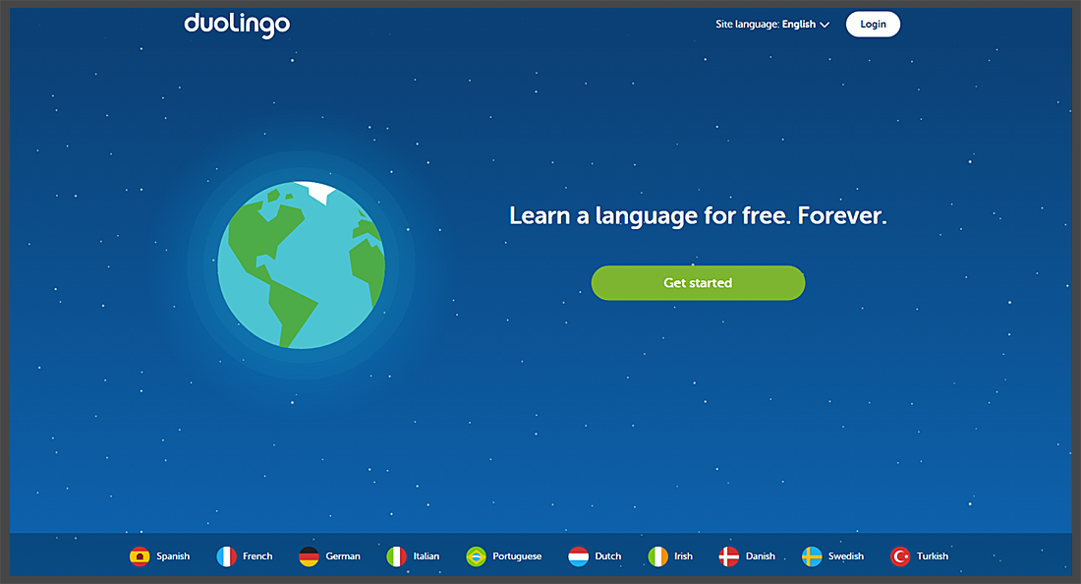

Figure Choose a language

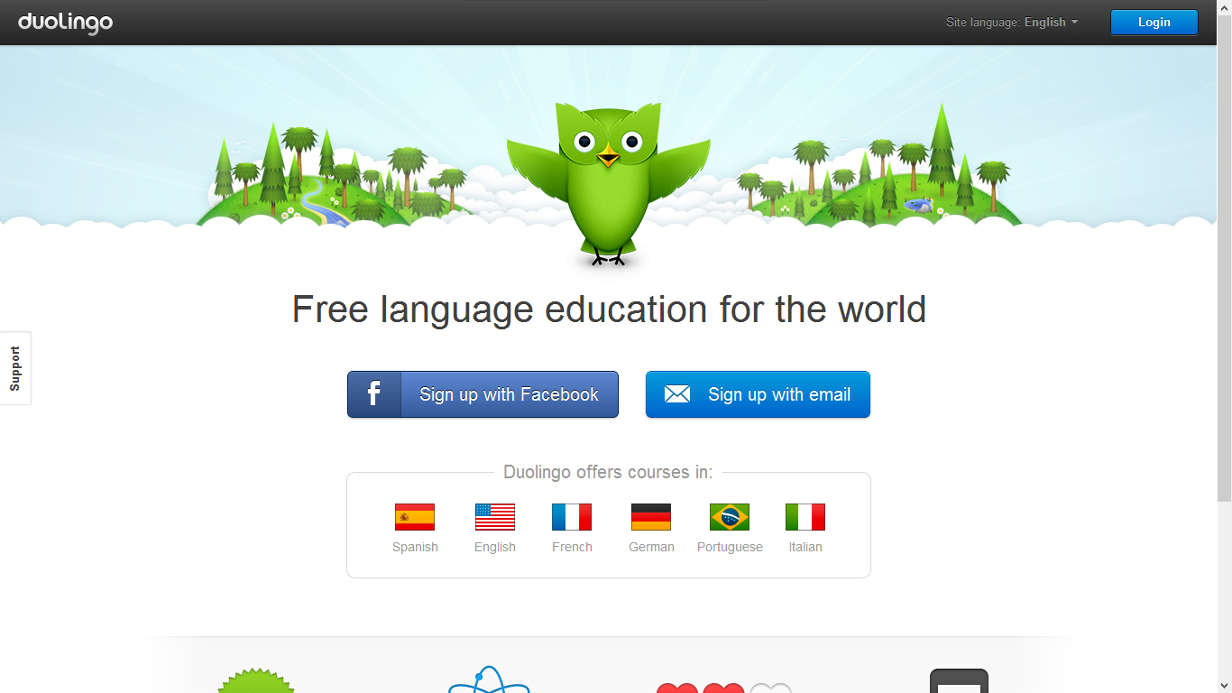

Figure Web Application in English

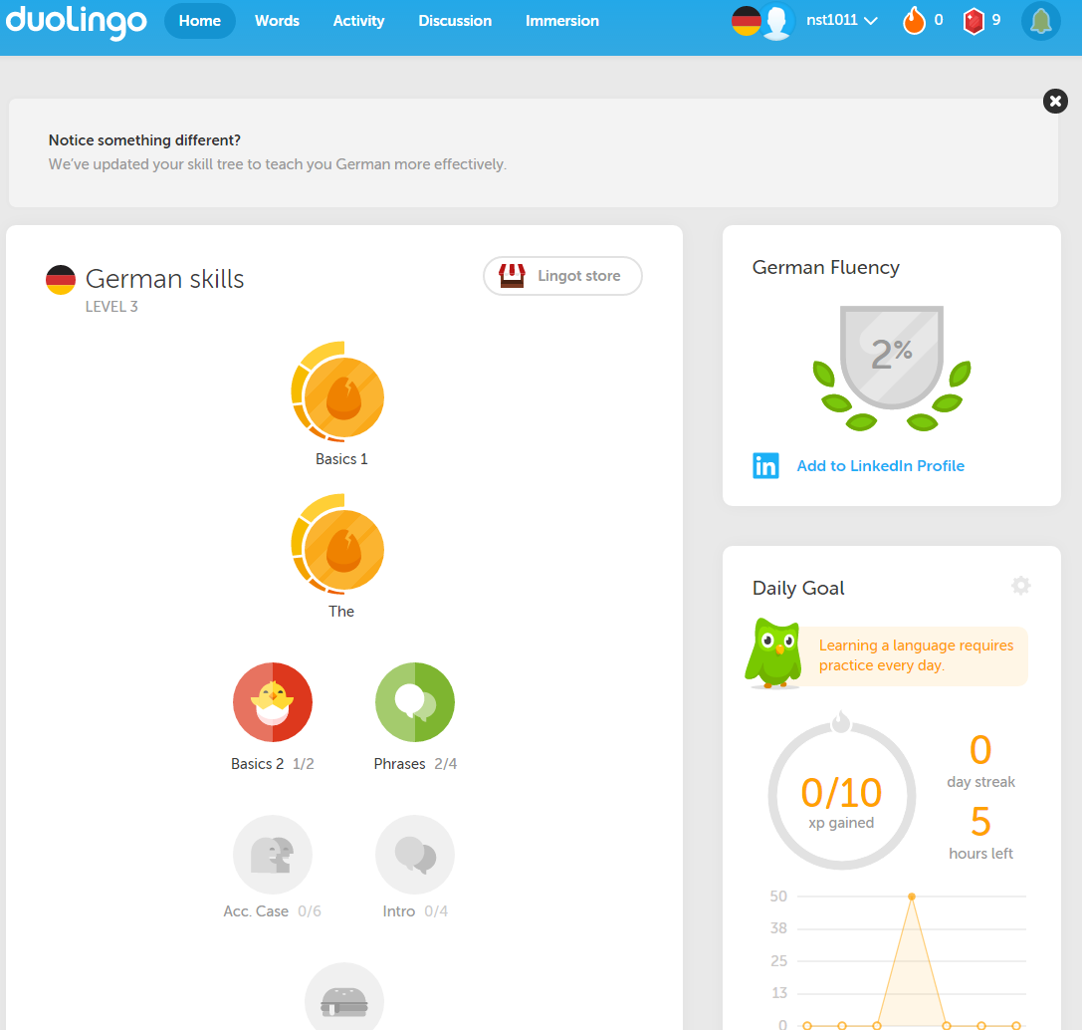

Figure Web homepage logged in

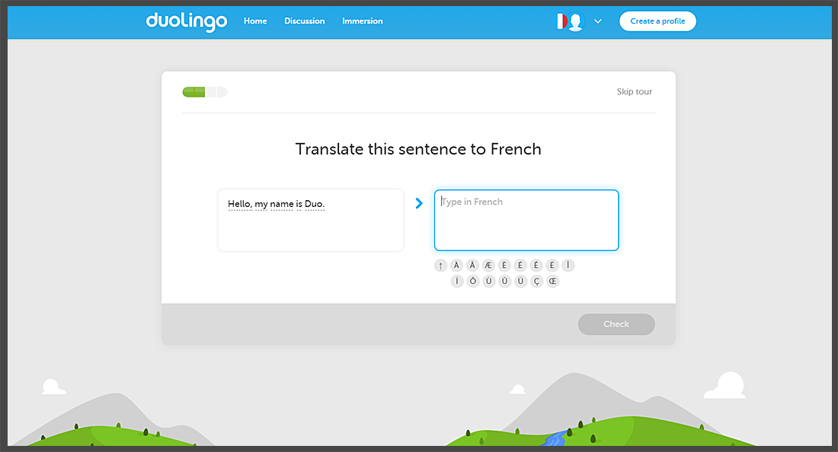

Figure Website version of English Learning French

# Appendix C

## Browser Mobile Version

# Appendix D

## Native Mobile Versions: Android, iOS, and Windows

### iOS App Screenshots

|  |  |  |
| --- | --- | --- |
| https://s-media-cache-ak0.pinimg.com/736x/ba/80/50/ba8050ebb26723fb6ab7e4ca348faf8e.jpg  Figure 25 Multiple languages available for native English speakers to learn | Figure 26 - iOS Application button | C:\Users\Nick\AppData\Local\Microsoft\Windows\INetCache\Content.Word\image58.png  Figure 27 Course completion page with progress streak for the week and total experience points earned |
| Figure 28 User profile options: progress sharing, my page url, daily streak, friends, and language options | Figure 29 User profile options list of friends and their experience points on a leaderboard | Figure 30 Languages that are out of beta for English speakers |
| Figure 31 Progress sharing with friends or teachers | weakest-words  Figure 32 Strengthen weak words now or later | Figure 33 Courses for native English or non-English speakers |
| Figure 34 French learning La fille (the girl) the boxes allow the user to organize possible correct answers into a sentence or phrase | Figure 35 French learning Une pomme (an apple) with sound and multiple options | Figure 36 Errors or inaccurate answers when learning |
| Figure 37 If you get an answer correct that may have alternative right answers recorded in the system, you will receive a message with tips | Screen Shot 2016-03-04 at 9.02.13 PM.png  Figure 38 Push notifications and reminders | |
| Screen Shot 2016-03-04 at 9.00.47 PM.png  Figure 39 Setup pages | | |

# Appendix E

## Gamification

|  |  |
| --- | --- |
| http://i.imgur.com/5oEZxGI.png?1  Figure 40 User Experience Award - the top most level is 25 then you can collaborate on the application | |
| Figure 41 User Profile Options: Languages the user is learning and their experience points including their daily streak | Screen Shot 2016-03-04 at 9.00.00 PM.png  Figure 42 Duo, the mascot, is always encouraging users |

# Works Cited

Chuang, G.-H., & Fong, J. (2009, August 5). *User Profile*. Retrieved March 10, 2016, from Listia: http://listia.com

Gigaom. (2013, 12 17). *Duolingo snags iPhone App of the Year*. Retrieved 02 21, 2014, from Gigaom: http://gigaom.com/2013/12/17/duolingo-snags-iphone-app-of-the-year/

Karch, A. (2015). *Duolingo Review: The Quick, Easy and Free Way to Learn A Language - Language Hacking and Travel Tips.* Retrieved March 4, 2016, from Fluent in 3 months: http://www.fluentin3months.com/duolingo/

Siegler, M. (2011, April 12). *Meet Duolingo, Google's Next Acquisition Target; Learn A Language, Help the Web*. Retrieved 11 21, 2014, from TechCrunch: http://techcrunch.com/2011/04/12/duolingo/

Szulborski, D. (2005). *This is not a game: A guide to alternate reality gaming.* Macungie, PA, USA: New-Fiction Publishing.

Tarter, I. (2013, October 2013). *Duolingo Review: 6 Ways to Get the Most Out of Duolingo* . Retrieved March 4, 2016, from Language Surfer: http://www.languagesurfer.com/2013/10/08/6-ways-to-get-the-most-out-of-duolingo/

Todd, D. M. (2012, July 3). *Ashton Kutcher Backs CMU Duolingo*. Retrieved July 13, 2012, from Gazette: http://www.post-gazette.com/stories/business/news/ashton-kutcher-backs-cmu-duos-startup-duolingo-641086/

Venture Capital Dispatch. (2012, June 19). *The Daily Start-Up: Kutcher-Backed Language Site Duolingo Finds Its Voice*. (M. Billings, S. Martin, D. Gage, R. Garland, B. Gormley, C. Zakrazewki, et al., Editors, & Venture Capital Dispatch, Editors of Dow Jones VentureWire) Retrieved July 13, 2012, from Wall Street Journal: http://blogs.wsj.com/venturecapital/2012/06/19/the-daily-start-up-kutcher-backed-language-site-duolingo-finds-its-voice/

von Ahn, Luis. (2011, November 30). *Duolingo Mobile*. Retrieved March 10, 2016, from Duolingo: https://en.duolingo.com/mobile

von Ahn, Luis. (2011, November 30). *Learn a language for free.* Retrieved March 4, 2016, from Duolingo: https://www.duolingo.com